***AIM:*** To design a project of led chaser.

***APPARATUS REQUIRED:*** 5 LED, Wires, Resistances, Arduino board, Breadboard.

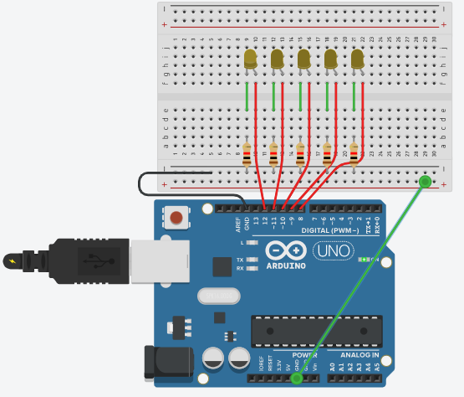***CIRCUIT DIAGRAM:***

***THEORY:***

Arduino is an open-source electronics platform based on easy-to-use hardware and software. Arduino boards are able to read inputs - light on a sensor, a finger on a button, or a Twitter message - and turn it into an output - activating a motor, turning on an LED, publishing something online.

***OBSERVATION:***

* When the circuit get completed , the light starts blinking in the LEDs

***PRECAUTIONS:***

* Connections must be neat and tight.
* The N-type of LED is to be connected to the ground properly.
* The code must be entered correctly.